BEC Salon COVID 19 Consent Form: 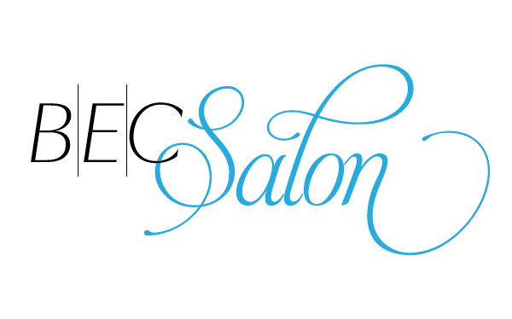
I, _____________________________________________, knowingly and willingly consent to have hair services performed by an employee of BEC Salon during the COVID-19 pandemic.

I understand the COVID-19 virus has a long incubation period during which carriers of the virus may not show symptoms and still be highly contagious. It is impossible to determine who has it and who does not, given the current limits in virus testing. _________ (initial)

I understand that due to the frequency of visits of other clients, the characteristics of the virus, and the characteristics of hair services, that I have an elevated risk of contracting the virus simply by being in the salon, ________(initial)

I confirm that I am not presenting any of the following systems of COVID-19 included but not limited to the following list. ________(initial)
• Fever – temperature
• Shortness of breath
• Loss of sense of taste or smell
• Dry cough
• Runny nose
• Sore throat

To prevent the spread of contagious viruses and to help protect each other, I understand that I will have to follow the salon’s strict guidelines. ________(initial)

I understand that air travel significantly increases my risk of contracting and transmitting the COVID-19 virus. ________(initial)

I understand that the CDC, OSHA and Board of Cosmetology and Barbers recommend social distancing of at least 6 feet. ________(initial)

I verify that I have or have not (circle one) traveled outside of Canada in the past 14 days to countries that have been affected by COVID-19. ________(initial)

I verify that I have or have not (circle one) traveled domestically within Canada by commercial airline, bus, or train within the past 14 days. ________(initial) If you have, please list:

Name: ________________________________________________________

Date: _________________________________________________________

Email: _________________________________________________________

